INFRATRACK
Eastern Mediterranean
Infrastructure & Energy Corridor Brief
SAMPLE EDITION — structure and live data, issued for evaluation
Issued 2026-09-02 · curated statuses re-verified at issuance · scoring s2p-0.1.0
Confidential when issued to a named client. Not investment advice.

1. Executive summary
- The East-Med electricity bridge became investable this month: France's Meridiam took majority ownership of the Great Sea Interconnector (Aug 2026), with Nexans contracted to accelerate seabed surveys — while Türkiye's maritime objections keep completion beyond 2029–30.
- Egypt is positioning as Europe's next power supplier: GREGY (3 GW to Greece) holds EU seabed-mapping funds and targets FID in H2 2026, backed by €690m of Egyptian grid upgrades.
- The corridor's logistics spine remains stressed: the July 2026 Red Sea blockade cut Bab el-Mandeb transits ~25%; Suez volumes have stabilized but stay subdued, repricing every East-Med port and LNG assumption.
- Asset base at a glance: 24 major ports, 30 LNG terminals, 53.2 GW operating generation, and 4 electricity interconnectors (6,000 MW built or planned) inside the corridor window.
- Net read: infrastructure momentum is real and increasingly French/EU-underwritten, but every corridor thesis must price two persistent frictions — Türkiye-adjacent maritime risk and Red Sea flow instability.

2. The corridor at a glance
Scope: Greece–Cyprus–Egypt–Levant window (19–36°E, 30–41.5°N), from InfraTrack’s live asset layers.
Indicator | Value
Major ports (large + medium, World Port Index) | 24
LNG terminals (all statuses, GEM) | 30
Electricity interconnectors (built + planned) | 4 — 6,000 MW
Maritime chokepoints tracked | 2
Operating generation capacity | 53.2 GW
Subsea sabotage incidents inside window | 0
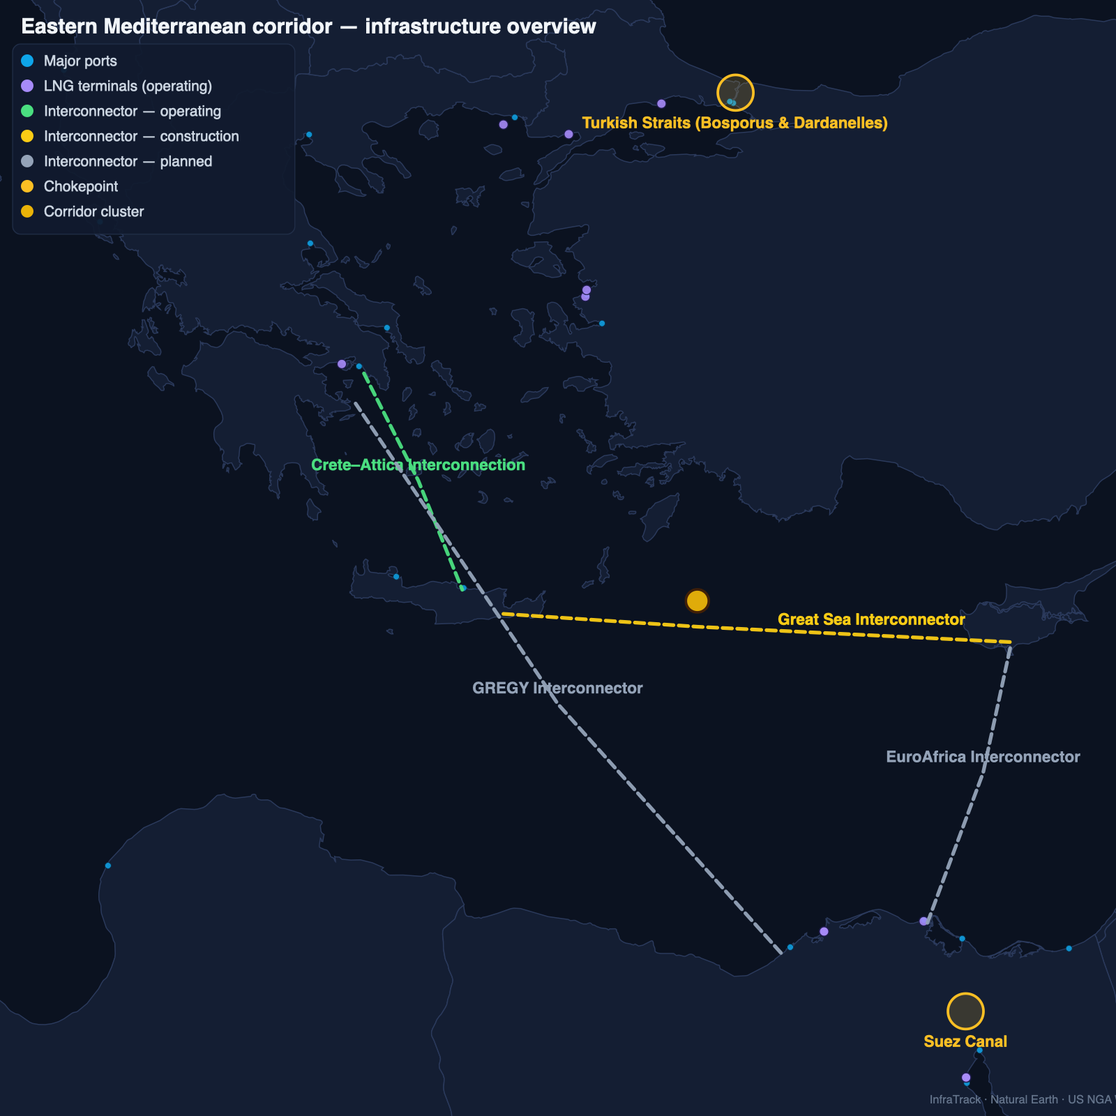
Figure 1 — Corridor infrastructure overview, rendered from InfraTrack live data

3. The electricity bridge
Four subsea HVDC projects define the corridor’s power story — one operating, one under construction, two competing for the Egypt export lane:
Link | Route | Status | Latest development
Great Sea Interconnector | Greece–Cyprus | Under construction · 1,000 MW | HVDC subsea link (898 km, deepest-laid power cable planned, €1.9bn, €657m EU CEF) connecting Crete to Cyprus, ending Cyprus’s status as the last non-interconnected EU member grid; phase 2 aims at Israel. Aug 2026: France’s Meridiam became majority shareholder of the project company (ADMIE retains a strategic role) and Nexans was signed to accelerate seabed surveys — but Türkiye’s maritime objections and financing friction have pushed completion beyond the 2029–30 target.
Crete–Attica Interconnection | Greece (mainland–Crete) | Operating · 1,000 MW | HVDC link between Attica and Crete, commissioned 2024 — the proving segment for the wider Greece–Cyprus corridor and the backbone that lets Crete absorb mainland renewables.
GREGY Interconnector | Egypt–Greece | Planned · 3,000 MW | Proposed ~950 km, 3,000 MW subsea HVDC link (ELICA/Copelouzos with ADMIE and Egypt’s EETC) exporting Egyptian renewables to Greece and the EU market. Momentum through 2026: €9.6m EU CEF seabed-mapping funds (Jan), route/cost study tenders under evaluation, FID targeted H2 2026, operation early 2030s; Egypt is laying grid-upgrade groundwork (€690m) for exports.
EuroAfrica Interconnector | Egypt–Cyprus | Planned · 1,000 MW | Proposed HVDC link between the Egyptian grid and Cyprus (2 GW planned, ~1,400 km full route), complementary/competing with the Great Sea corridor southward leg. Still in planning as of Aug 2026: first-stage completion pushed from 2023 to ~2029, with renewed feasibility work after Egypt’s currency crisis.
Statuses verified against live reporting on 2026-09-02. Per-project sources in the appendix.

4. Chokepoints & flow risk

Suez Canal
The corridor’s defining maritime chokepoint: ~12–15% of global trade and a major share of Europe-bound LNG and container traffic. Red Sea security shocks (2023–) rerouted volumes around the Cape; a renewed Houthi blockade against Saudi-linked shipping in July 2026 cut Bab el-Mandeb transits ~25% — canal traffic has stabilized but remains subdued, with VLCCs lightening loads and the Sumed pipeline absorbing flows.

Turkish Straits (Bosporus & Dardanelles)
Black Sea grain, crude and product flows compress through two narrow straits governed by the Montreux Convention — the corridor’s northern valve and a standing geopolitical pressure point.
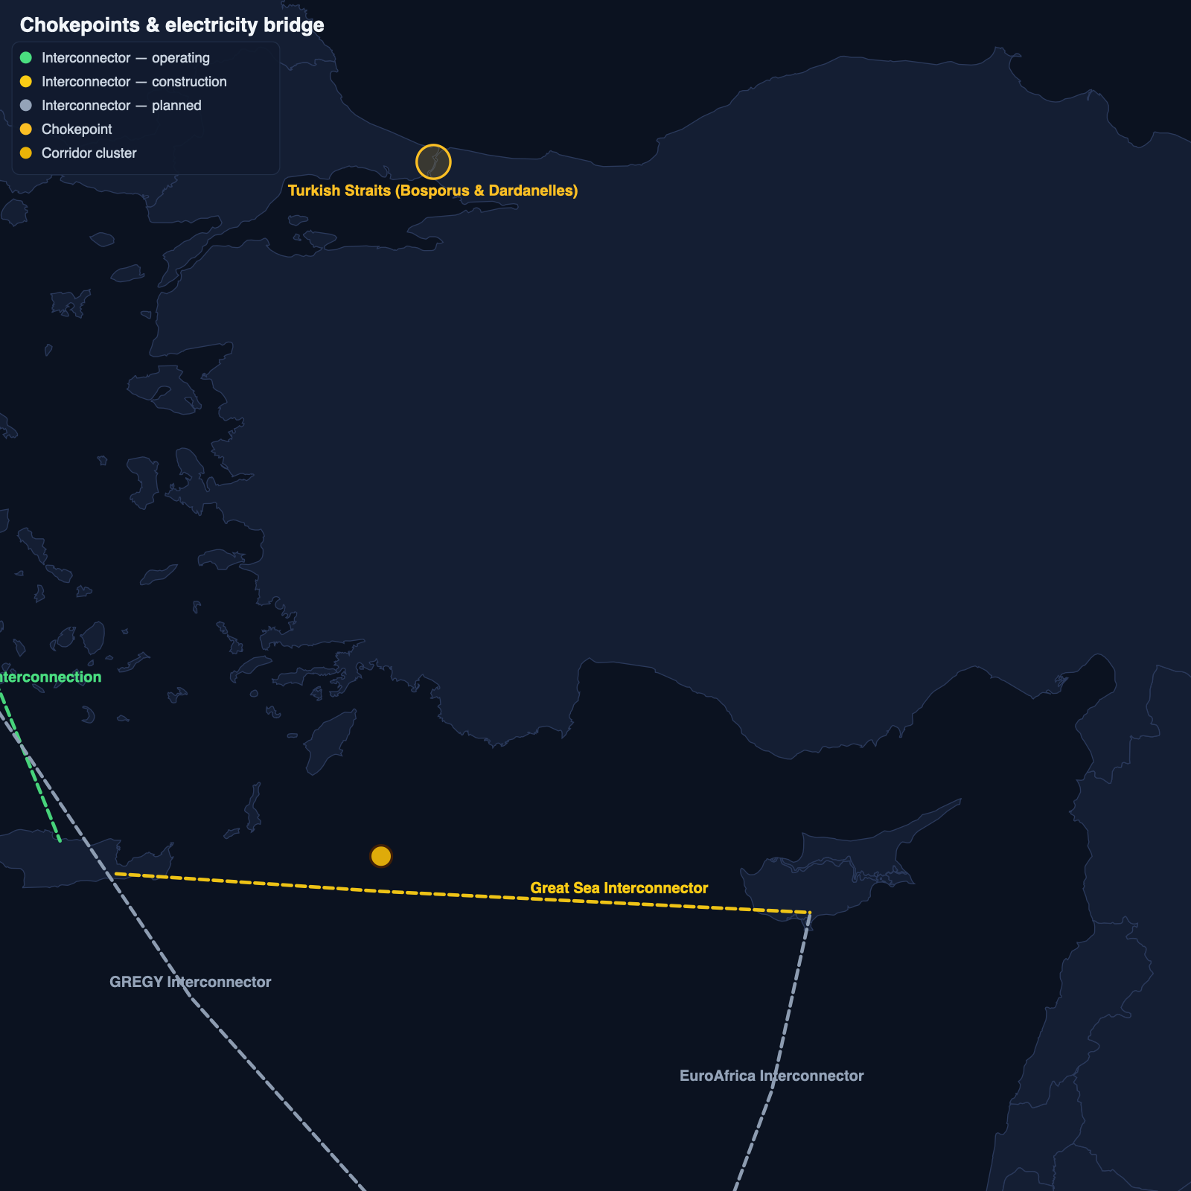
Figure 2 — Chokepoints and the electricity bridge

5. What to watch — next two quarters
- Great Sea Interconnector under Meridiam: survey completion pace and whether the Cyprus–Israel leg re-enters scope.
- GREGY final investment decision (targeted H2 2026) — the corridor’s biggest single go/no-go signal.
- EuroAfrica financing: whether Egypt’s macro stabilization revives the Cyprus leg or GREGY absorbs the lane.
- Red Sea blockade trajectory: Bab el-Mandeb transit counts and Suez draught-restriction workarounds (VLCC lightening, Sumed flows).
- [Client-specific watch items are added here on issuance.]

6. Methodology & sources
Every InfraTrack dataset passes a source-registry gate recording license, commercial-use rights and review dates before it can appear in the product or a deliverable. Full methodology: infratrack.pages.dev/methodology/
Source | Covers | License
Global Energy Monitor | Pipelines, LNG, power plants | CC BY 4.0
US NGA World Port Index | Ports | Public domain
WRI Aqueduct 4.0 | Water stress | CC BY 4.0
World Bank Open Data | Grid indicators | CC BY 4.0
OpenStreetMap (Overpass) | Data centers | ODbL 1.0
InfraTrack research compilation | Corridor projects, chokepoints, opposition & incident events | Own compilation; per-item source links
Data: Global Energy Monitor (CC BY 4.0) · Ports: World Port Index (US NGA) · Water risk: WRI Aqueduct 4.0 (CC BY 4.0) · Grid indicators: World Bank Open Data (CC BY 4.0) · © OpenStreetMap contributors (ODbL)
Disclaimer: comparative screening analysis built on public data for research and commercial decision support. Not investment advice, engineering due diligence, or a substitute for site-specific studies. Aggregate exposure analysis only — no operational vulnerability detail. Data may not reflect real-time conditions.

